Architecture of DevOps
05 February 2026
22:18

Plan - Manager
- Project plans
- Requirements
- Design
- Create documents
- Stored in a Shared Repo.
- Files - requirements.md
(Azure Boards) - To keep track of workflows
- Tickets, Tasks, Features,etc
- Questions/ Doubts/ Discussions between product owners, testers, coders, etc

(Azure Repos) - enables to use git workflows
- Commits
- Pushes
- Branches
- Tags
- PRs

Code - Developer
- Host your code private
- Not limited to only code repo's
- Collaborate on the code ( Reviews, PR, Branch Policies )
- Developer -
  - Create a branch
  - Ask for review
- Reviewer
  - Reviews the changes
  - Finally add it.
- Once the code is merged, the pipeline is triggered.
- Example - index.html, app.js, Main.java

Build - DevOps Engineer
- Compile and package into artifacts
- Final Output : Artifacts
- CI Pipelines start from here
- Running build scripts/dockerfile
- Main.java -> .jar file - using Maven Tool
- Dockerfile -> docker image
- Finally, the output is pushed to central repository
- Incase of docker image, it is pushed to central registry.
- Artifacts is created and is ready for testing, release and deployment

(Azure Pipelines) - Pipeline is triggered

Test - Tester Team
- Verify's whether build is made properly or not
- Perform Integration test, regression test, unit test
- Manual or Automatic Test
- Create test scripts(.sh) and test plans
- Output is stored in Azure Reports
- Automatic Test
  - Select Tool
  - Define scoop
  - Planning and Design
  - Test Execution - Why Automated
    - Quality Assurance: Manual testing is a tedious task that can be boring and at the same time error-prone. Thus, using automation testing improves the quality of the software under test as more test coverage can be achieved.
    - Error or Bug-free Software:
    - No Human Intervention:
    - Increased test coverage: Automation testing ensures more test coverage in comparison to manual testing where it is not possible to achieve 100% test coverage.
    - Testing can be done frequently: Automation testing means that the testing can be done frequently thus improving the overall quality of the software under test.
- Reports processed in pipeline.
- If test passes, pipeline proceeds
- File - .xml file reports
(Azure Tests) - Specific service provided by azure.
It is used to store all the test scripts,
Check the reports of previously run tests

Release - DevOps Engineer
- Fully Tested Build is ready for production
- Engineers create a versioned release artifacts
- Eg: myapp.1.0.tar.gz
- All the release artifacts are stored in Artifact Registry
- Also checks for pre-production deployment
Deploy - Operations Team
- They provision and configure the production environment.
Eg: Deployment configurations (e.g. deployment.yaml
- create, modify, and destroy the foundational infrastructure components like virtual machines
- Infrastructure and deployment code resides in version control; the actual application is transferred to the target servers or cloud environment.
Operate - Operations Team
  - maintains the live system
  - They manage configuration
  - perform routine tasks such as scaling resources, or restarting services
  - Eg: updating a config file on production

Monitor - Manager
  - Finally, the Manager (or Team Lead) drives the continuous improvement phase.
  - They gather feedback from monitoring, user reports, and retrospectives to refine the process.
  - This might involve updating the requirements or backlog (improvements.md or similar). For example, if monitoring shows a performance bottleneck, the Manager adds a performance requirement to the project plan.
  - Artifacts: Improvement items and updated plans (e.g. a retrospective document, updated requirements.md, new Jira stories).
    - Location: These updates go into the project management system or version control (similar to initial planning artifacts).
    - Next: The improvements form the input for the next planning phase, closing the loop. The next Plan phase begins with these revised requirements, ensuring lessons learned carry forward

Pipeline

condition: succeeded()
jobs:

DEPLOYMENT
- stage: Deploy
displayName: Deploy Stage
dependsOn: Test
jobs:

# -------- DEV --------
- deployment: DeployDEV
displayName: Deploy to DEV
environment: DEV
strategy:
runOnce:
deploy:
steps:
# Download the SAME artifact again
- task: DownloadPipelineArtifact@2
inputs:
artifact: 'node-build'
path: 'dist'

# Deployment logic (example)
- script: echo "Deploying to DEV using build artifact"

# -------- TEST --------
- deployment: DeployTEST
displayName: Deploy to TEST
environment: TEST
dependsOn: DeployDEV
strategy:
runOnce:
deploy:
steps:
- task: DownloadPipelineArtifact@2
inputs:
artifact: 'node-build'
path: 'dist'

- script: echo "Deploying to TEST using same build"

# -------- PROD --------
- deployment: DeployPROD
displayName: Deploy to PROD
environment: PROD
dependsOn: DeployTEST
strategy:
runOnce:
deploy:
steps:
- task: DownloadPipelineArtifact@2
inputs:
artifact: 'node-build'
path: 'dist'

- script: echo "Deploying to PROD using same verified build"
Environment | Who uses it | Stability | Approval | Risk
DEV | Developers | Low | ❌ No | Low
TEST | QA / Testers | Medium | ❌ Sometimes | Medium
PROD | End users | High | ✅ Yes | High
trigger:
branches:
include:
- main

# Use Microsoft-hosted Linux agent
pool:
vmImage: 'ubuntu-latest'

stages:

# ==================================================
# BUILD STAGE
# ==================================================
- stage: Build
displayName: Build Stage
jobs:
- job: BuildJob
displayName: Build Job
steps:

# Pull source code from repo
- checkout: self

# Install Node.js
- task: NodeTool@0
inputs:
versionSpec: '18.x'
displayName: 'Install Node.js'

# Install dependencies
- script: npm install
displayName: 'Install dependencies'

# Build the application
# Example output: dist/ or build/
- script: npm run build
displayName: 'Build application'

# 🔴 IMPORTANT PART 🔴
# Publish build output as a pipeline artifact
# This is where the build is STORED
- task: PublishPipelineArtifact@1
inputs:
targetPath: 'dist'
artifact: 'node-build'
publishLocation: 'pipeline'
displayName: 'Publish build artifact'
TESTING
- stage: Test
displayName: Test Stage
dependsOn: Build
jobs:
- job: TestJob
displayName: Test Job
steps:

# Download the build artifact from Build stage
- task: DownloadPipelineArtifact@2
inputs:
artifact: 'node-build'
path: 'dist'
displayName: 'Download build artifact'

# Install Node.js
- task: NodeTool@0
inputs:
versionSpec: '18.x'
displayName: 'Install Node.js'

# Install dependencies (needed to run tests)
- script: npm install
displayName: 'Install dependencies'

# Run tests
- script: npm test
displayName: 'Run tests'

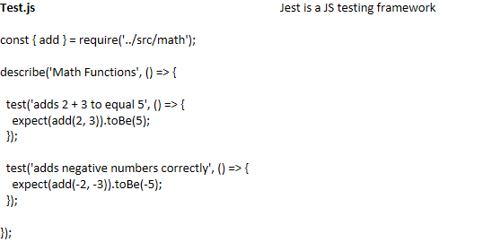

What happens:
  - Jest finds files ending with .test.js
  - Runs each test
  - If any test fails → exit code ≠ 0
  - Azure DevOps fails the Test stage
  - Deploy never runs

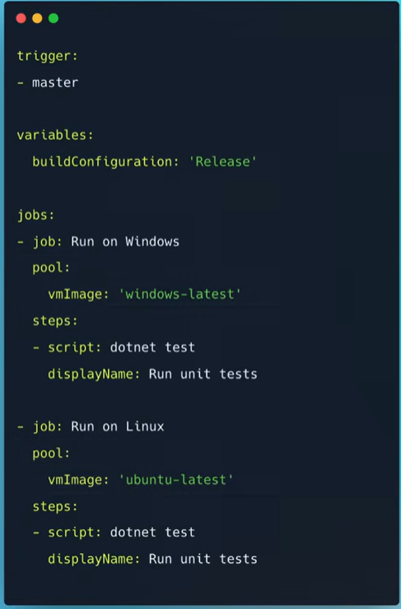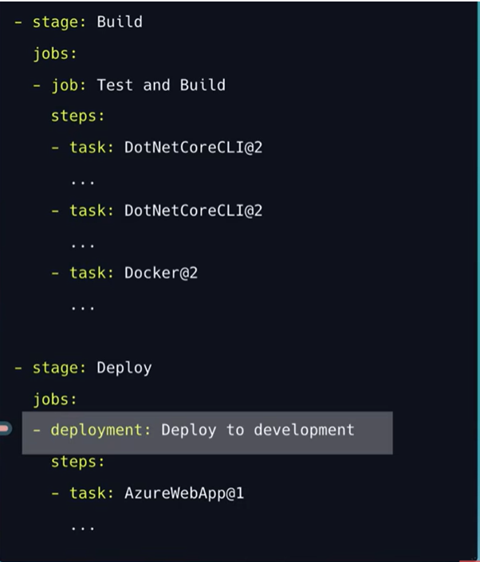

SSH
06 February 2026
09:35

SSH (Secure Shell) is a network protocol that lets you securely access and manage another computer over an unsecured network
It mainly replaces older, unsafe methods like Telnet and FTP, which sent data (including passwords!) in plain text.

Purpose
SSH exists to solve three big security problems:
  - Confidentiality – Data is encrypted, so attackers can’t read it
  - Authentication – You know you’re connecting to the real server
  - Integrity – Data can’t be modified in transit without detection
In short: safe remote access + safe data transfer.

Utilization
  - Remote Server Login
System administrators use SSH to:
  - Log into Linux servers
  - Restart services
  - Install software
  - Monitor logs
Example : SSH Authentication with GitHub

  - Secure File Transfer
SSH powers secure file transfer tools:
  - SCP (Secure Copy)
  - SFTP (Secure File Transfer Protocol) - Banking systems
Example : scp index.html user@192.168.1.10:/var/www/html/

  - Tunneling & Port Forwarding
SSH can securely tunnel other protocols through encryption.
  - Accessing a Private Database

-> ssh -L 3306:localhost:3306 user@db_server_ip
What happens :
localhost:3306 → SSH tunnel → remote MySQL

Encryption
06 February 2026
09:35

Architecture Diagram of DevOps - An entire overview of How DevOps work occur.
Continuous Integration in Detail
SSH (Secure Shell)
Encryption
Transforms readable data into unreadable format (CipherText)
  - Authorized persons with the correct decryption key can convert cipher-text back to plain text.

Key’s Generation
  - Substitution Technique –
Substitution technique involves the replacement of the letters by other letters and symbols
  - Transposition Technique:
In transposition technique, the identity of the characters remains unchanged, but their positions are changed to create the ciphertext.
Types Of Encryption
  - Symmetric Key Cryptography
Symmetric Key Cryptography is an encryption system where the sender and receiver of a message use a single common key to encrypt and decrypt messages.
  - Symmetric Key cryptography is faster and simpler but the problem is that the sender and receiver have to somehow exchange keys securely.
  - The most popular symmetric key cryptography systems are Data Encryption Systems (DES) and Advanced Encryption Systems (AES) .

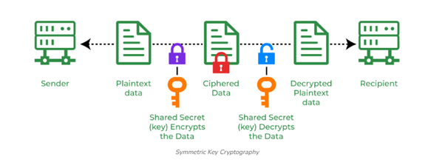
Data Encryption Standard (DES)
DES (Data encryption standard) is an older encryption algorithm that is used to convert 64-bit plaintext data into 48-bit encrypted ciphertext.
  - It uses symmetric keys (which means same key for encryption and decryption).
  - It is kind of old by today’s standard but can be used as a basic building block for learning newer encryption algorithms.
AES (Advanced Encryption Standard):
AESs a popular encryption algorithm which uses the same key for encryption and decryption.
  - It is a symmetric block cipher algorithm with block size of 128 bits, 192 bits or 256 bits.
  - AES algorithm is widely regarded as the replacement of DES (Data encryption standard) algorithm.

2. Hash Functions
Hash functions do not require a key. Instead, they use mathematical algorithms to convert messages of any arbitrary length into a fixed-length output, known as a hash value or digest.
SHA-1:
  - It was designed to ensure data integrity by converting any input into a fixed-size 160-bit (20-byte) hash value.
MD5:
  - MD5 produces a 128-bit hash value (32-character hexadecimal number) from input data of any size.
MD6:
  - It was created to be highly secure and suitable for modern computing systems, including multi-core processors.
MD6-128
MD6-256
MD6-512
SHA-256
  - The SHA-256 algorithm belongs to the family of the SHA 2 algorithms.
  - It generates a fixed 256-bit (32-byte) hash value from input data of any length.

3. Asymmetric Key Cryptography
In Asymmetric Key Cryptography a pair of keys is used to encrypt and decrypt information. A sender's public key is used for encryption and a receiver's private key is used for decryption.
RSA (Rivest-Shamir-Adleman):
RSA is an basic asymmetric cryptographic algorithm which uses two different keys for encryption. The RSA algorithm works on a block cipher concept that converts plain text into cipher text and vice versa

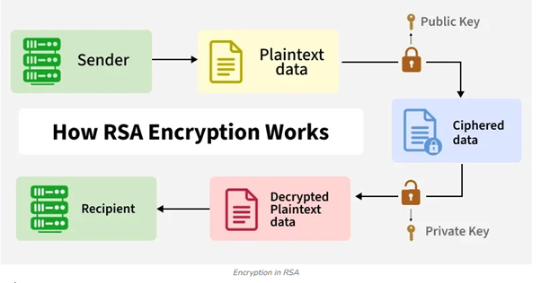
Encrypting large data? --> Symmetric
Sharing keys securely? → Asymmetric
Storing passwords / checking integrity? → Hashing

SVN vs Git
06 February 2026
09:35

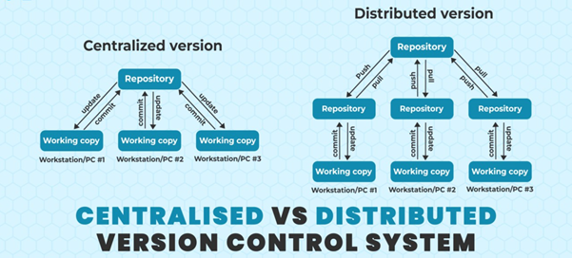

SVN (Subversion) is a centralized version control system (VCS) used to track changes to source code, documents, and project files.

Action | Meaning
svn checkout | Get a working copy of the repository
svn update | Pull the latest changes
svn commit | Push your changes to the central repo
svn branch / svn merge | Create and merge branches (often avoided due to complexity)

1. Checkout
Each developer downloads the project:
svn checkout http://example.com/svn/project
2. Developer A makes changes
  - A edits login.js
  - A tests locally
  - A commits:
svn commit -m "Fix login validation"
3. Developer B makes changes at the same time
  - B edits the same file without updating first
  - B tries to commit → SVN rejects the commit:
Commit failed - out of date
4. Developer B updates
svn update
  - If the same lines were edited → B must manually resolve conflicts
  - After resolving:
svn commit -m "Add forgot password logic"
5. Developer C merges a branch
  - Branching is heavy and slow in SVN
  - C must manually merge changes and handle conflicts
  - Merging large branches often becomes risky and painful
Limitations
  - Centralized = single point of failure
  - Merging is hard
SVN merging is slow, complicated, and error-prone:
  - Branching discouraged → fewer feature branches
  - Teams often committed directly to trunk → more breakage
  - Slow performance
a network connection
History checks are server-dependent
  - Limited offline work

Branching
SVN branches exist, but they behave very differently from Git branches, and merging in SVN has historically been:
  - more manual
  - more error-prone
  - slower
  - lacking true merge tracking
Command
svn merge ^/branches/feature-abc
svn resolve --accept=working file.txt
All merging work is done on your local machine, and SVN historically didn’t track merge metadata well.
  - SVN: cannot rewrite history

SVN branching (directory-based)
Git branching (pointer-based)
Simple Example — Same Merge in SVN vs Git
Scenario:
  - Dev A and Dev B both edit login.js
  - Both finish their feature branches
  - Both merge back to trunk / main
In SVN
  - Dev A merges first → ok
  - Dev B tries merge → conflicts
  - SVN cannot find a good merge-base (historically)
  - B resolves manually
  - Commits merged result
Often:
  - Subtle conflicts
  - Confusion about which revisions were merged
  - Repeat merges reintroducing old conflicts
In Git
  - Dev A merges → merge commit
  - Dev B merges → Git knows the merge-base
  - Git auto-resolves non-overlapping changes
  - B fixes remaining conflicts, commit merge
Much cleaner and more automated.

“SVN merging is painful” even though branches exist
Because branching isn't the problem — merge tracking is.
SVN merges often require:
  - manual selection of revision ranges
  - manual resolution
  - slow server interactions
  - limited metadata to remember past merges
Git merges:
  - are local
  - use a DAG graph
  - have strong merge-base detection
  - track merge history cleanly

Agile and Waterfall
06 February 2026
09:35

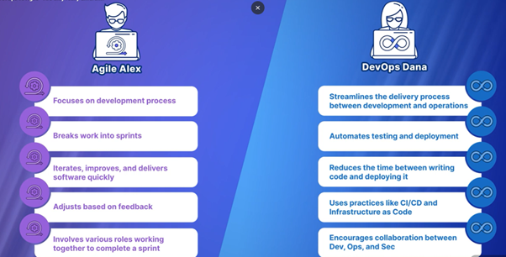
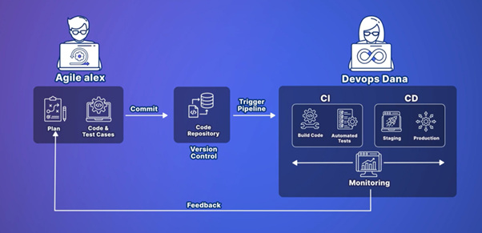

Task 2
06 February 2026
10:38

Task to be Performed
  - Architecture Diagram of DevOps - An entire overview of How DevOps work occur.
  - SSH
What is SSH?
Purpose and Utilizations of SSH
  - Environments to run pipeline or SDLF?
  - Continuous Integration in Detail - https://www.youtube.com/watch?v=G1u4WBdlWgU
  - Agile, Waterfall Models VS DevOps
  - SVN
Why earlier SVN was used and Now we transferred to Git
  - Types of Encryption Level
-> RSA
-> Base 64
  - What is containerization
  - why we need containerization
  - Why we need docker
  - where we can use docker
  - Create docker file - (why we need docker file)

